**A genome-wide EMS mutation probability map of *Caenorhabditis elegans*: predicting valuable mutations with a machine learning model**

Guo Zhengyang

Advisor: Iino Yuichi

**Abstract**

Chemical mutagenesis is widely used in a forward genetics approach in model animals. Collecting mutants from numbers of mutagenized animals based on a particular phenotype is a relatively high-throughput process. However, mapping and eventually characterizing the responsible mutation(s) on the genome are labor-intensive if using conventional approaches such as SNP-based mapping. Whole genome sequencing (WGS) is a reliable tool for analyzing the genetic variations after mutagenesis. With this technique, several strategies that facilitate mapping mutations on a restricted region of the chromosome have been developed, but it remains challenging to efficiently determine candidate genes for further analyses. In this article, with a newly developed pipeline, an ethyl methane sulfonate (EMS)-induced mutation probability map of C. elegans was made by analyzing correlations between the propensity of EMS-induced mutations and features of each nucleotide on the genome such as adjacent sequences and the properties of DNA-binding protein analysis. It will provide a precise prediction of the mutation probability of each genomic position. Analyzing WGS data sets of several large-scale screens with this map precisely predicted the mutation rate of each gene and successfully identified casual nucleotide changes. This approach would provide a unique opportunity to facilitate identification of valuable mutations in genetic screens.

**Introduction**

Genome-wide chemical mutagenesis is widely applied in a forward genetics approach in many model organisms, through which we can gain a deeper insight into gene functions and interactions. Ethyl methane sulfonate (EMS) is thought to induce the ‘G/C’ to ‘A/T’ transition on a genome-wide scale, making it a common mutagen applied in forward and reverse genetic screening. Generally, mutagenesis is a high-throughput procedure, especially when using model organisms with high reproduction rates, such as plants, bacteria, yeast, and nematodes.

Whole-genome sequencing (WGS) has become a reliable tool for identifying causal mutations since about 15 years ago (Sarin, Prabhu, O'Meara, Pe'er, & Hobert, 2008). Before the WGS technique emerged, the traditional method of determining responsible mutation was difficult and phenotype relying (Brenner, 1974). Now, with the help of alignment and annotation software, WGS can typically detect about 250~400 mutations in an EMS-treated *C. elegans*. Despite its high efficiency in detecting mutations, finding the mutation responsible for the observed phenotype is still difficult because many silent mutations also exist . Many strategies, termed ‘mapping by sequencing’, have been developed to filter out casual mutations. A widely used approach in *C. elegans* exploits the single nucleotide polymorphisms (SNPs) between two wild-type strains, the Hawaiian (HA) strain CB4856 and the Bristol strain N2 (which is usually used as standard wild type in research), characterized by over 100,000 polymorphisms. (C. elegans Sequencing Consortium 1998; (Doitsidou, Jarriault, & Poole, 2016; Hillier et al., 2008; Vergara et al., 2014; Wicks, Yeh, Gish, Waterston, & Plasterk, 2001)). In brief, hybrid N2-derived mutant and HA animals are generated by crossing, and recombinant inbred lines (RILs) are established from the hybrids. Then, these RILs are subjected to WGS. The ratio of SNP type along the genome maps responsible mutations to the regions where the N2/HA ratio was high in RILs with phenotype (Doitsidou, Poole, Sarin, Bigelow, & Hobert, 2010). Many improvements have been made, such as EMS density mapping (Drake & Baltz, 1976; Flibotte et al., 2010; Sarin et al., 2010), variant discovery mapping (VDM) (Cheesman et al., 2016; Minevich, Park, Blankenberg, Poole, & Hobert, 2012), and sibling subtraction method (SSM) (Joseph, Blouin, & Fay, 2018) to overcome the caveats of the HA strain, which is mainly because of the unpredictable unstable phenotype penetrance due to the background polymorphisms in this strain. These mapping procedures narrow down the chromosomal region where the responsible mutation resides, but tens of candidate mutations are typically left within the region. Therefore, identifying responsible mutations requires further characterization of these candidates one by one, though one can choose plausible candidate such as nonsense or missense mutations that affect the primary sequence of proteins (Sarin et al., 2008).

These mapping strategies are time-consuming and against the high-throughput design of forward genetics approaches, making it impossible to obtain multiple alleles at a time. Furthermore, one may overlook the responsible genes in poorly mapped samples. Focusing on missense or nonsense mutations might result in overlooking mutations in regulatory elements and non-protein-coding genes.

Here I describe a novel approach to detect the responsible mutation directly from the WGS datasets of the isolated mutants. With WGS data from the million mutation project (MMP) and the modENCODE project, an EMS mutation probability map was built to predict the anticipated frequency of random mutation of every base pair on the *C. elegans* genome so that the mutations enriched by a genetic screening based on a particular phenotype can be distinguished from those random mutations. Thus, this approach predicts valuable mutations without establishing RILs, enabling the big-scale data analysis of a high-throughput genetic screening.

**2. Material and method**

**2.1 WGS data of the million-mutation project.**

WGS data of the million-mutation project can be accessed through the official page of Simon Fraser University (<http://genome.sfu.ca/mmp/>). In the total of 2007 mutated strains, VC20xxx strains (a total of 737 strains) were isolated after EMS mutagenesis. Among those 737 strains, 265169 variations were found at a 15x fold coverage. Raw sequencing data of fastq format are available from [Home - SRA - NCBI (nih.gov)](https://www.ncbi.nlm.nih.gov/sra).

**2.2 DNA-binding protein data**

Mainly CHIP-chip and CHIP-seq data (table 1)("An integrated encyclopedia of DNA elements in the human genome," 2012; Muers, 2011), which can be accessed from the modENCODE project ([www.modencode.org](http://www.modencode.org/)) and visualized version from Wormbase Genome Browser ([JBrowse (wormbase.org)](https://wormbase.org/tools/genome/jbrowse-simple/)).

**2.3 Pentabase bias calculation from the MMP dataset**

The Pentabase bias of EMS was calculated with the MMP dataset and reference genome of C. elegans WScel235 as follows (see also Fig2.A-H):



…………………………………………………count of mutated pattern in the MMP dataset

𝐶′…………………………..………………count of the same pattern in the reference genome

**2.3 Data preprocess and machine learning.**

CHIP-chip and CHIP-seq data were smoothed so as to better fit the realistic situation of the worm genome. (Fig.2 A). A python script was used to smooth these data by calculating the convolve average every 100 bp alongside each chromosome. The pentabase preference of the EMS was also calculated with another python script. Finally, the dataset was used to train a random forest regressor model. The possibility of each base pair being mutated was calculated so that the mutation rate of the whole gene could be calculated as follows:

$P_{gene}=\sum_{i ∈gene}{P_{i}}$

$P_{i}$…………………………………………………………mutation frequency of base i

$P_{gene}$……………………………………………………...mutation frequency of a gene

Variation number for each gene has to obey the binomial distribution during the mutagenesis event, so the expected variation number of each gene is calculated as follows:

$E\left(x\right)=nP_{gene}$.

$n$…………………………………………………………total number of sequenced strains

Variations in experimental conditions, including slightly different stages of the worm being mutated, different temperatures, or different concentrations of EMS buffer, may result in a different mutation rate. Therefore, I split the mutation frequency of each base into two parts:



$α_{0}$……………………………………………………………………experimental error

$f\left(x\right)$………………………prediction by a machine learning model from feature-set x

When the Genome-wide map was made, it can be applied in any screening of *C. elegans* by calculating the correct $α$:

$${{P^{'}}_{gene}=α}_{1}\sum_{i ∈gene}{f\left(x_{i}\right)}=\frac{{\overline{N}}_{1}}{{\overline{N}}_{0}}α_{0}\sum_{i ∈gene}{f\left(x_{i}\right)}$$

${\overline{N}}_{0}$…………………………………average mutation number of MMP model per sample

${\overline{N}}_{1}$………………………………………….…average mutation number of other datasets

Therefore, I can further calculate the fold change and p value of each gene in each screening.

**2.4 Model evaluation and feature importance calculation.**

The model is evaluated via the function below comparing the expected mutation rate of each gene with the number in the MMP dataset:

$$R^{2}=1-\frac{SSR}{SST}=1-\frac{MSE}{Var}$$

$MSE$…………………………….…mean square error between prediction and mutation dataset

$Var$………………………………………………………variance in mutation number of each gene

The permutation score is used to evaluate the importance of each feature. Each feature is replaced with a random noise that shares the same value distribution with the original data several times. Then, the model trained by the original dataset was used to make predictions again with the dataset with a noise feature. The permutation importance is calculated as:

$$i_{j}=R^{2} - \frac{1}{n}\sum_{n=1}^{n}{{R^{2}}_{n,j}}$$

$i_{j}$…………………………………………………………….….…the importance of each gene

${R^{2}}_{n,j}$……………………………………….………………...…feature j being shuffled n times

The pentabase preference of EMS is the leading feature, making it ambiguous to tell which DNA-binding protein feature is more important. It is assumed as follows:



$x'$….…………………………………………………….….……DNA-binding protein feature

$P_{0}$…....……………………………..……………………...…Pentabase bias of each base pair

By observing each screening, $α_{0}*P_{0}$ can be calculated as the EMS pentabase preference observed in the distinct experiment dataset, leaving the DNA-binding protein feature alone so that the importance can be evaluated in an alpha-independent model.

All calculation and model trainings are done via python scripts, which can be accessed on GitHub ([young55775/Genetorch-developing (github.com)](https://github.com/young55775/Genetorch-developing))

All data were normalized to 0~1 while representing by heatmap and line chart as below:

$$V=\frac{v-min⁡(v)}{\max\left(v\right)-min⁡(v)}$$

**2.6 Worm culture**

*C. elegans* were maintained under 20 ℃ according to the standard method. Nematode growth medium (NGM) (table 2) with Escherichia coli OP50 seeded on it was used to cultivate these worms.

Most of these strains and screening results were from our cooperating laboratory and many had not been published until the time of writing this article.

**2.7 EMS mutagenesis**

Worms synchronized at the late L4 stage were collected with 4 mL M9 buffer. These worms were incubated in 50mM EMS buffer at room temperature with rotation (for how long?). Then these worms were washed three times with M9 buffer and cultured under standard conditions. 20 hours later, the adult worms were bleached to obtain their eggs (F1). These eggs were distributed to ~100 9-cm NGM plates. Consequently, there were 50~100 eggs per plate. Adult animals with the target phenotype were collected and individually cultured. After further examination of their progeny, their whole-genome sequences were analyzed with a Illumina next-generation sequencer.

**2.6 WGS data analyze**

The raw reads obtained by next-generation Illumina sequencer were assessed for duplication and quality with FastQC and were trimmed using Trim_galore (version 0.4.4) to remove the adaptor and low-quality sequences. After that, clean reads were aligned to the reference genome (WS235) using BWA-MEM2 (version 2.2) with default parameters. In all these sequencing results, > 20x average coverage is ensured. Variations were detected using freebayes (version 1.3.6) and annotated using SnpEff. Finally, a filter was set that I only call variations satisfied: sequence depth >5, allele frequency > 0.8.

**3. Result**

**3.1 The distribution of EMS-induced variation is not genome-wide uniform in the MMP dataset.**

The million mutation project discloses WGS data of 737 EMS-mutagenized N2 animals that contains 265169 single-nucleotide variations (SNVs) and indels. By analyzing the distribution of EMS-induced mutations on the genome (Fig. 1A), I noticed a non-uniform distribution with ‘hot spots’, which showed a higher SNV density than average, and ‘cold spots’, which showed lower density. At first, I assumed that the ‘G/C’ contents would influence the mutation frequency since EMS mainly introduce ‘G/C’ to ‘A/T’ transitions. Correlation analysis revealed that the distribution of ‘G/C’ pairs only partially explained the frequency of mutations (Fig.1 A, B).

Furthermore, the mutation frequency differed by chromosome (Fig. 1C). Chromosome X appeared to have a higher mutation frequency, while chromosome IV had a lower frequency than others. These results indicated that the EMS-induced variations are not uniformly distributed on the genome probably due to the difference of local features of chromosome regions. Therefore, the mutation probability must be predictable with a mathematical model once the regulatory factors are identified.

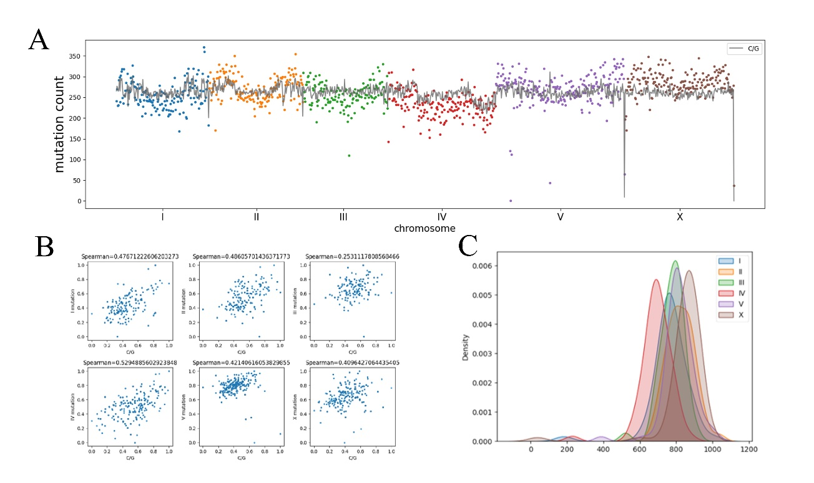

**Figure 1. Ununiform distribution of EMS-induced SNV**

A)Scatter and line plot represents mutations in the MMP dataset, scatter plot shows the mutation number on each chromosome, each dot represents the number of mutated bases within every 100,000 bp. Line plot represents relative ‘C/G’ base pair concentration B) Scatter plot of the relationship between ‘C/G’ base pair contents and the number of mutations from the MMP dataset of each chromosome respectively. C) Kernel density estimation plot of the number of mutations on each chromosome. Chromosome X has a higher mutation frequency while the mutation frequency of Chromosome IV is lower than others.

**3.2** **The EMS mutation probability depending on the nearby flanking sequences**

A previous study in rice (*Huanghuazhan*) indicated that the efficiency of EMS mutagenesis may be affected by the nearby flanking sequences (Tang X et al., 2021). To see if similar effects are observed in *C. elegans*, I compared the distribution pattern of the right (5′) four (+4/+3/+2/+1) and the left (3′) four (-4/-3/-2/-1) nucleotides next to the mutated bases (Fig.2 E-H) with that of all bases on the genome (Fig. 2 A-D). If EMS randomly induced mutations irrespective of flanking sequence, the two distribution patterns should be similar. The results of chi-square test show that the (+2/+1) and (-1/-2) of the C/G base pair substantially impact the EMS mutagenesis efficiency, which can be used to predict the mutation frequency bias. Based solely on the above-mentioned Pentabase bias, I made an EMS mutation frequency map, of which the result is not far from the ‘C/G’ concentration-based prediction. Here, taking the second-long gene in *C. elegans*’ s genome, *ttn-1*, as an example, the comparison of this map with the actual data revealed a ‘silent’ region with over 10000 bp in length where EMS-induced mutation is suppressed (Fig. 2I, J).

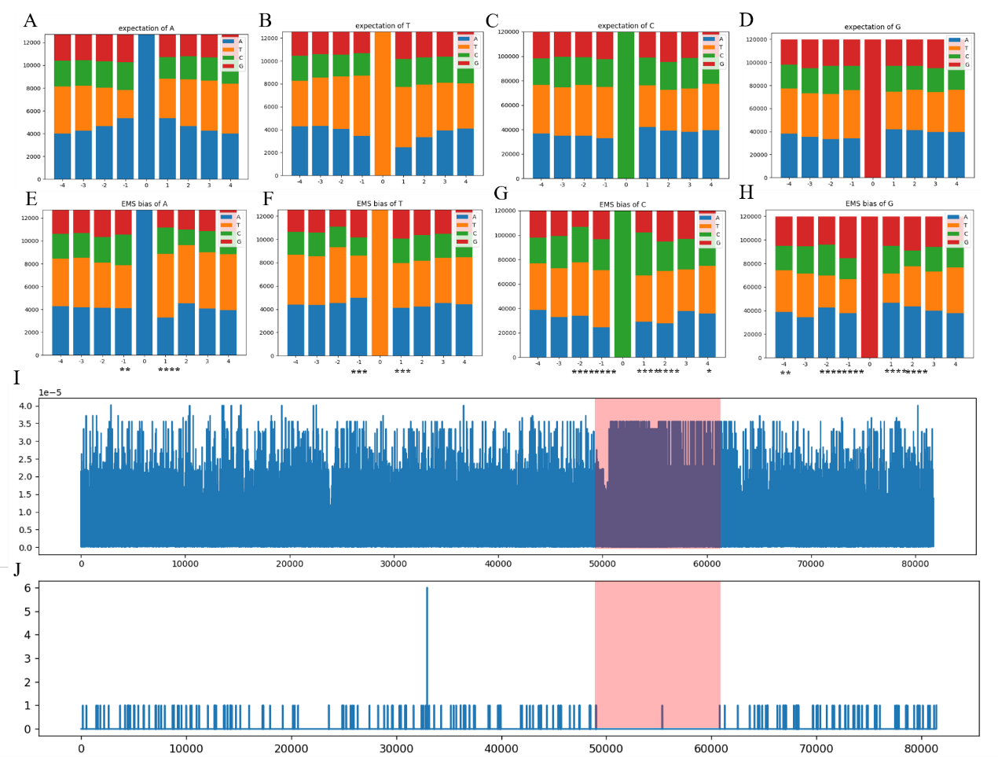

**Figure 2. Adjacent nucleotides affect EMS-induced mutation**

The distribution patterns of adjacent nucleotides of the genome of *C. elegans* and EMS-induced mutations. (A-D) Nucleotide distribution of standard N2 genome sequences. The number with -/+ indicates the left (5′)/right (3′) position to the nucleotide at position zero which was focused on the panel. For example in panel A, adenine (A, at the position 0) tends to have A as both left and right adjacent neighbors rather than other nucleotide species on the genome of N2. (E-H) Nucleotide distribution around the mutated nucleotides in the MMP dataset. Note that distribution patterns of adjacent nucleotide differ from that of the genome. Chi-square test; * p<0.05, ** p<0.01 *** p<0.001 **** p<0.000, difference between the corresponding distribution in (A-D), which was set as the expectation value when EMS introduce a mutation on the ‘C/G’ base pairs. ‘T/A’ pairs were not similarly affected. I) EMS mutation frequency map of the *ttn-1* gene (Chromosome V: 6,120,909~6,202,632) solely based on the above-calculated Pentabase bias. (J) The actual mutation numbers of the *ttn-1* region in the MMP dataset. The red block represents the ‘silent region’, inconsistent with the EMS mutation map in (I). X tick 0 point represents the 6120909th base on chromosome V + chain.

**3.3 Typical ‘silent regions’ were observed in the MMP dataset, consistent with the DNA-binding protein modification data.**

There are many possible explanations about the ‘silent regions’. It may be associated with the chromatin state (Mohammad & Jha, 2022), for example. Tightly supercoiled DNA is devoid of interaction with outside substances (Bowater, Bohálová, & Brázda, 2022), or some DNA binding proteins may protect its target sequence from DNA-interacting chemicals (Arnold & Barton, 2013). Therefore, I investigated the dataset of DNA binding proteins and their DNA-binding protein modifications, hoping to find some clues consistent with the silent regions. Some histone modification and transcription factor binding activity data are shown as examples (Fig.3 A, B). Histone H3 and H4 modification datasets showed that the silent region of *ttn-1* has a quite distinguishable pattern of histone modification and distribution. The *unc-62* and *unc-39* transcription factor binding activity also show distinct patterns in this region, indicating a very special region which may cause the inhibition of mutagenesis.

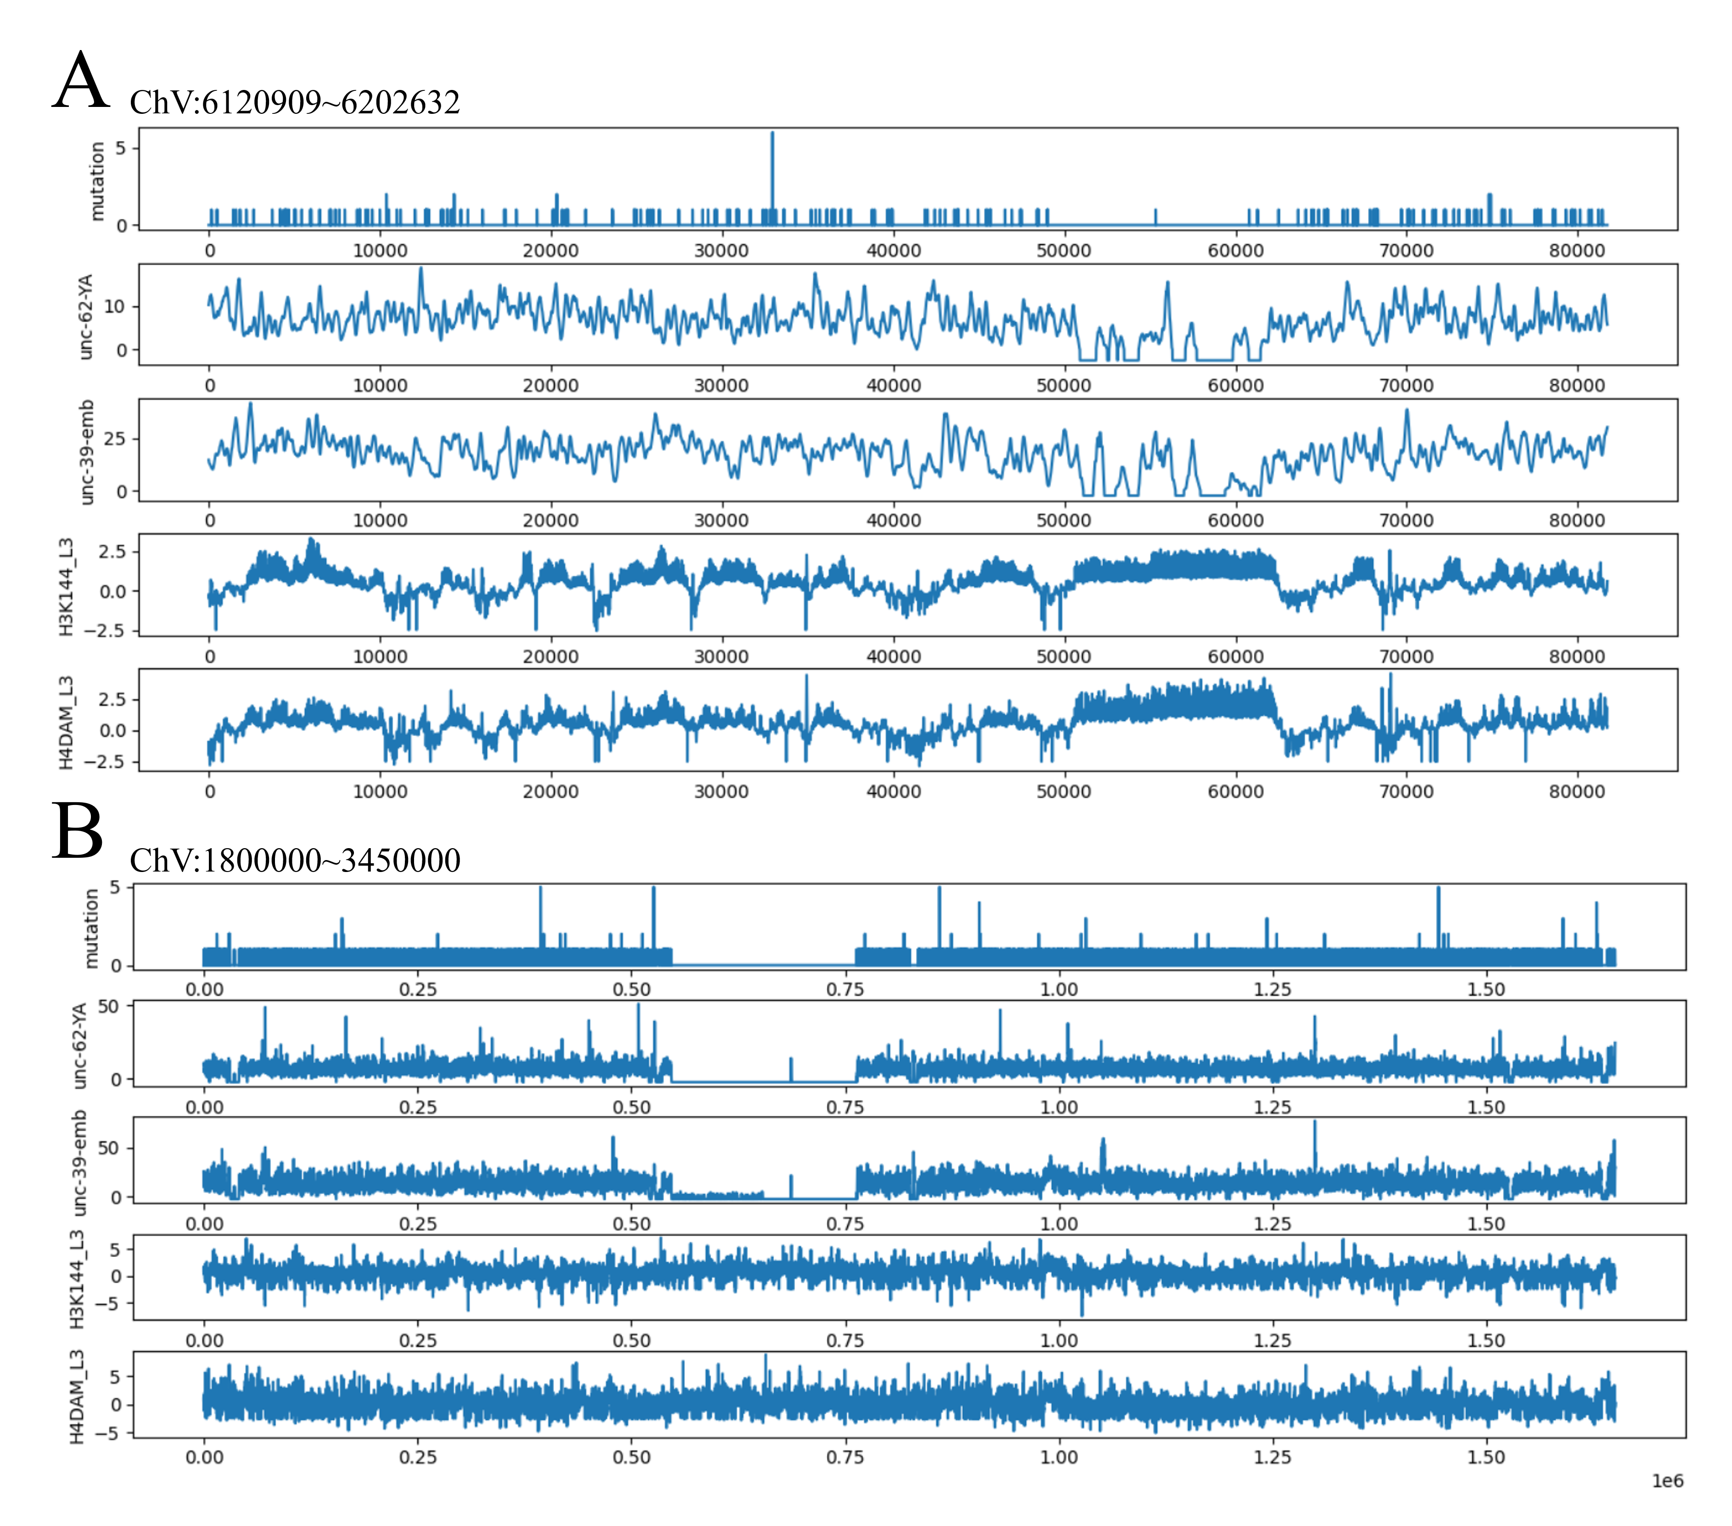On chromosome V, there is another silent region of over 200,000 bp in length (Fig.3 C, D). At the same position, *unc-62* and *unc-39* binding activity was abnormal as well. However, histone H3 and H4 did not show the same, distinguishable patterns as seen in *ttn-1* data, suggesting that special regions containing a boosted or inhibited mutation probability may have various causes, which, the DNA-binding proteins might be the direct cause or coincidently be consistent for the same reason. Whatever the reason is, it seems plausible to identify the binding patterns of DNA-binding proteins and analyze the relationship between them and mutation probability. The largest *C. elegans* genome database, WormBase (wormbase.org), accumulates the results of over 600 DNA-binding protein modification datasets alongside the genome. These data provide an opportunity for us to systematically analyze the relationship between DNA-binding protein modifications and mutation frequency by machine learning.

**Figure 3. Mutation numbers in the MMP data shown parallel with the DNA-binding protein features**

A) mutations of gene *ttn-1* on chromosome V and the DNA-binding protein ChIP-seq/ChIP-chip data at the same positions. X tick 0 point represents the 6120909th base on chromosome V + chain. B) mutations of chromosome V at position 1,800,000~3,450,000 and the DNA-binding protein ChIP-seq/ChIP-chip data at the same position. X tick 0 point represents the 1,800,000th base on chromosome V + chain.

**3.4** **Random forest regressor can predict the mutation frequency based on the pentabase mutation probability and DNA-binding protein features.**

Here I trained two regression models using a machine learning algorithm, random forest regressor. I built two models differently. Both models are based on the hypothesis that if two base pairs have the same property and are within the same environment, they will be equally mutated by EMS. Random forest model will give the classification standard of each condition and calculate the average mutation probability of each condition (Fig. 4A, Material and method). As described in the schematic diagram, the two guanine residues colored in orange had the same DNA-binding protein features and the pentabase bias, they are considered to have equal mutation rate. If one of them was mutated, the mutation probability of such guanine residue is calculated as 0.5. The difference between the two models is that, model I will directly provide each base's mutation frequency. Model II predicts mutation probability as the product of the flanking sequence and DNA-binding protein feature effects, which can help us learn more about the role of these DNA-binding proteins for mutation occurrence . (Fig.4 A-B)

In model I, mutation frequency is predicted using the flanking sequence and all the selected DNA-binding protein features. In brief, it is a $P=αf\left(x\right)$ model (Fig.4 A). $α$ for experimental error due to the different concentrations of EMS used, different ages of worms, different temperatures, etc., which may result in a variation in EMS mutagenesis efficiency.

In model II, the mutation frequency of each gene can be calculated as since we assume that the interaction between DNAbp features 𝑥 and Pentabase bias is (Fig.4 B). Random forest regressor is applied to calculate the 𝑓(𝑥) of each model independent of the Pentabase bias. In that case, the dependent variable is the quotient of the actual count of mutation cases on the base pair and the Pentabase bias depending on the flanking sequences around it, which can be presented as.

While comparing the mutation number in the MMP dataset with the total mutation expectation every 100000 bp, the previously unexplained mutation probability variation (Fig.4 C) was fully demonstrated in both Model I and Model II. (Fig.4 D, E). Then I looked into the total 44,761 genes, the mutation number accurately matches the predicted expectation. (Fig.4 F). When I look closely at the map created by this model, almost every silent region is considered (Fig.4 H-L). An EMS mutation probability map is made based on the 737 EMS mutated strains from the MMP project and 22 DNA-binding protein features. Although there are over 600 DNA-binding protein datasets available, those selected 22 features have been able to build a reliable model already.

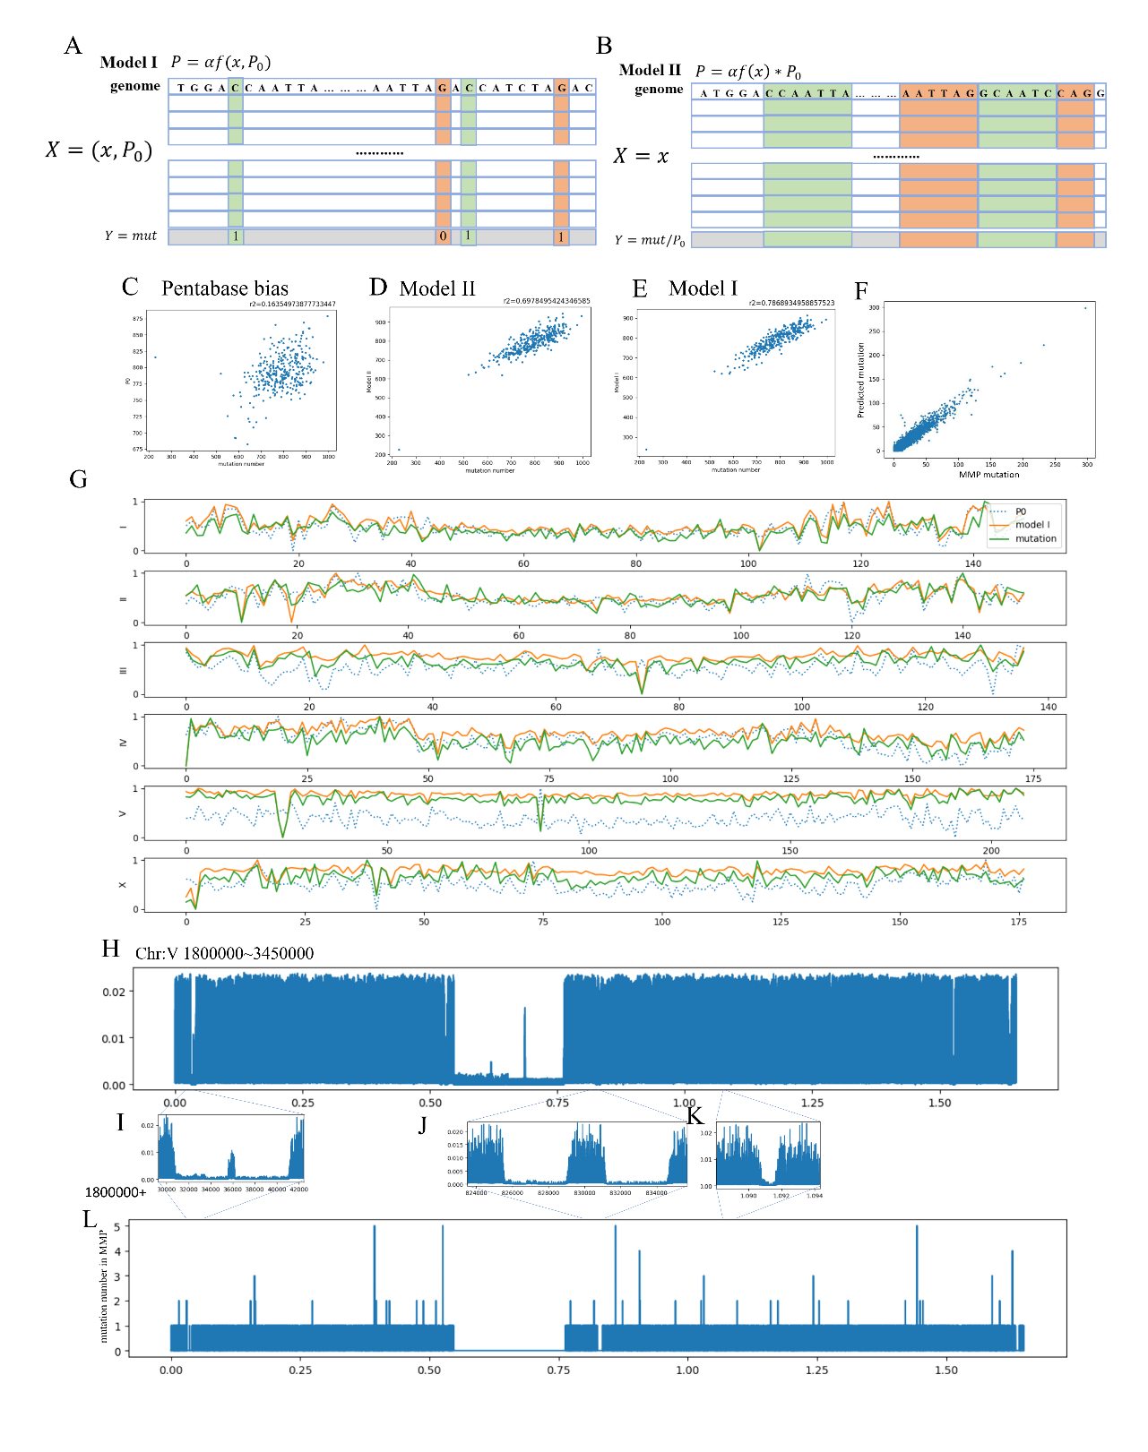**Figure 4. Mutation frequency can be predicted with two different machine-learning models.**

A-B) Schematic diagram of two different random forest models. A) In model I, mutation frequency is predicted directly by DNA-binding protein features and the pentabase sequence at once. For example, if the two guanine residues colored in orange had the same DNA-binding protein features and the pentabase bias, they are considered to have equal mutation rate. If one of them was mutated, the mutation probability of such guanine residue is calculated as $\frac{1}{2}$, similarly, the mutation probability of the cytosine which is colored green is 1. B) In model II, the calculational approach is much alike that in Model I except that the mutation frequency is calculated by the DNA-binding protein features separately from pentabase bias. C) Correlation between the mutation number in every 300,000 bp in the MMP dataset (that is, actual mutation number) and that predicted by the model in which solely pentabase bias had been considered. D) Correlation between the actual mutation number and the result of model II. E) Correlation between the actual mutation number and the result of model I. F) Correlation between the number of mutations predicted by model I and the actual mutation number in 44,671 *C. elegans* genes which were mutated in the MMP dataset. G) Line chart that represent actual mutation number, prediction of model I, and prediction by the pentabase bias in every 100,000 bp along with the chromosomes. H-L) Comparison between the model the MMP dataset. H) Prediction of model I on Chromosome V 1,800,000~3,450,000. I) - K) Enlargement of H). L) Mutation number reported by the MMP dataset in the same region. X tick 0 point represents the 1,800,000th base on chromosome V + chain.

**3.5 Valuable mutations discovered by comparing the WGS set with the EMS mutation probability map**

In both models, α was a variable determined by the experimental error and the real EMS mutagenesis efficiency which can be influenced by various reasons. Roughly, α can be applicable to selection of valuable genes in novel genetic screen by comparing the mutation frequency of particular gene in the MMP dataset with that in a novel WGS dataset of a screen. If a gene showed a mutation frequency statistically higher than expected in a pool of mutants with particular phenotype, one can consider the gene was responsible for that phenotype. Here, I analyzed novel WGS datasets obtained by genetic screenings using EMS as the mutagen. In two suppressor screening experiments that respectively obtained 94 and 438 suppressor mutants, 3 and 2 uncharacterized genes, respectively, were detected and experimentally confirmed as responsible (Fig.5 A, B). In addition, another WGS dataset of 256 Dumpy (short and fat) mutants was also analyzed, and previously characterized dumpy genes were found to be over-mutated than expected (Fig.5 C). The number of genes that cause Dumpy phenotype is expected to be larger than that of suppressor screenings. Still, the model correctly predicted many Dumpy-related genes (Brenner, 1974; Cho, Choi, Kim, Ahnn, & Lee, 2021) (including uncharacterized genes that need to be experimentally confirmed) and fewer suppressor mutations in different sets of WGS data, suggesting that the model is robust to the differences in different types of experiments.

Consideding that it is difficult to obtain many independent mutants with desired phenotypes, as an example of a small dataset of the suppressor screening, a dataset that consists of WGS data of 6 suppressors of *hecd-1* loss of function strain (Ike, Tomioka, & Iino, 2022), was analyzed. *otub-3* was detected to be a candidate gene in this experiment. *otub-3* encodes an otubain deubiquitylating protease homolog, a type of cysteine-type deubiquitinase, and may be involved in protein deubiquitination (Zhu, Fu, Li, Liu, & Zhang, 2021), thus may have a related 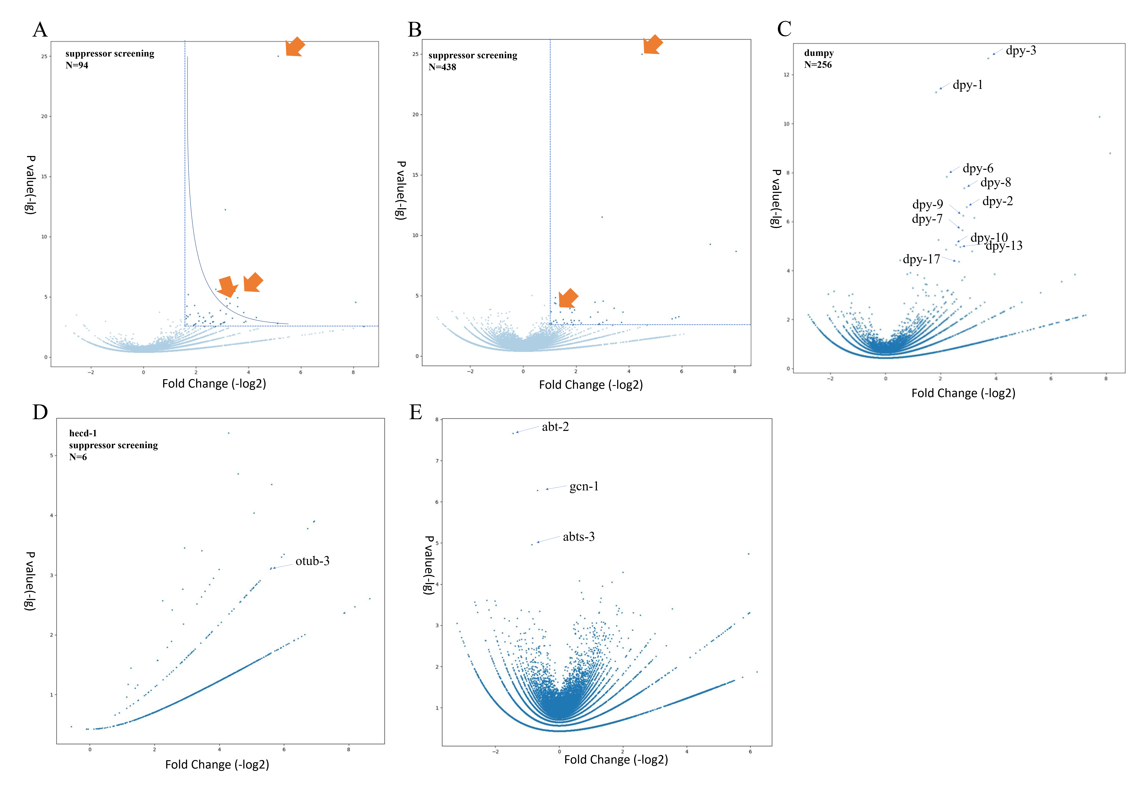function to *hecd-1.*

**Figure 5. Predict valuable mutations with the EMS mutation probability map.**

A) volcano plot of a suppressor screening experiment with 94 samples, orange arrows indicate genes that were experimentally confirmed. B) volcano plot of a suppressor screening experiment with 438 samples, orange arrows are confirmed genes. C) volcano plot of a Dumpy screening experiment with 256 samples. D) volcano plot of a suppressor screening experiment of *hecd-1* with 6 samples. E) volcano plot of the MMP dataset compared with the EMS probability map. Note that part of the data such as some gene names cannot be shown because they have not been published yet.

**3.6 Permutation importance evaluation of each feature reveals the difference in the areas that each feature has an effect.**

Although as an ensemble algorithm, it is difficult to exactly know how this kind of model works in an explainable way. It is essential to understand the interaction of features which provide the predictive accuracy. In model I, pentabase bias was the most impactful feature, and it made difficult to compare the importance of each DNA-binding protein features. Although model II was not as reliable as model I, it still provided a relatively accurate prediction, which means it can be used to assess the contribution of each DNA-binding protein feature independent of pentabase bias.

Permutation importance was used to evaluate each feature (Breiman, 2001). Each feature was randomized keeping the same distribution as the original feature values and the prediction was made using the new dataset with randomization. Replacement usually makes prediction worse than the original feature combinations. Contribution of each feature was evaluated by calculating mean square error and $r^{2}$ change (Altmann, Toloşi, Sander, & Lengauer, 2010)).

Features differently contributed to the prediction (Fig. 6A). Surprisingly, the most important feature was the number of chromosome on which the mutations are located. Transcription factor binding (ChIP-seq data of unc-62-YA and W03F9.2), histone H3 modifications (ChIP-chip data of H3K35me3-LTEMB) and DNA-binding proteins (Chip-seq of LEM2-MXEMB and HPL2) were important features for the accuracy of prediction. Interestingly, unc-62-emb, which represents UNC-62-binding at embryonic stage, was not as crucial as unc-62-YA of young adults,

suggesting that stage-specific DNA-binding property of UNC-62 affects the efficiency of EMS mutagenesis.

To investigate whether these features contribute equally to the high-frequency and low-frequency regions, the mutation number was counted every 100,000 bp and then divided into high-frequency regions (14,400,000 bp in total) and low-frequency regions (13,500,000 bp in total), respectively, by the mutation number beyond and below the average ± standard deviation. (Fig.6 B). I found that DNA binding of two transcription factors, unc-62-YA and W03F9.2, strongly contributed to the prediction of low-frequency regions. DNA binding proteins, HPL2 and LEM2-MXEMB were rather considered when predicting high-frequency regions. To visualize the importance of these features in different regions, the feature importance was calculated every 100,000 bp and sorted by mutation frequency (Fig.6 D). Unc-62-YA and W03F9.2 were two most important features highly related to extremely low-frequency regions, consistent with the above results. These transcription factors seemed to be paralleled with some histone modification data in this importance evaluation. HPL2 and LEM2_MXEMB appears to be equally important alongside the heatmap.

To visualize how these features work on chromosomes, the permutation score was scaled every 100,000 bp alongside the chromosomes (Fig. 6C). In these maps, HPL2 and LEM2-MXEMB seemed to be spatially separated: LEM2 tended to contribute intermediate region of chromosomes while HPL2 tend to affect both ends of the chromosomes. LEM2 is a nuclear membrane protein with lamin binding activity. Loss of lem-2 results in centrosome attachment defective in early embryo in some alleles (Sonnichsen et al., 2005). HPL2 is a HP1-like heterochromatin protein. The difference of localization of these DNA binding proteins might result in the differences of affected region along the chromosome.

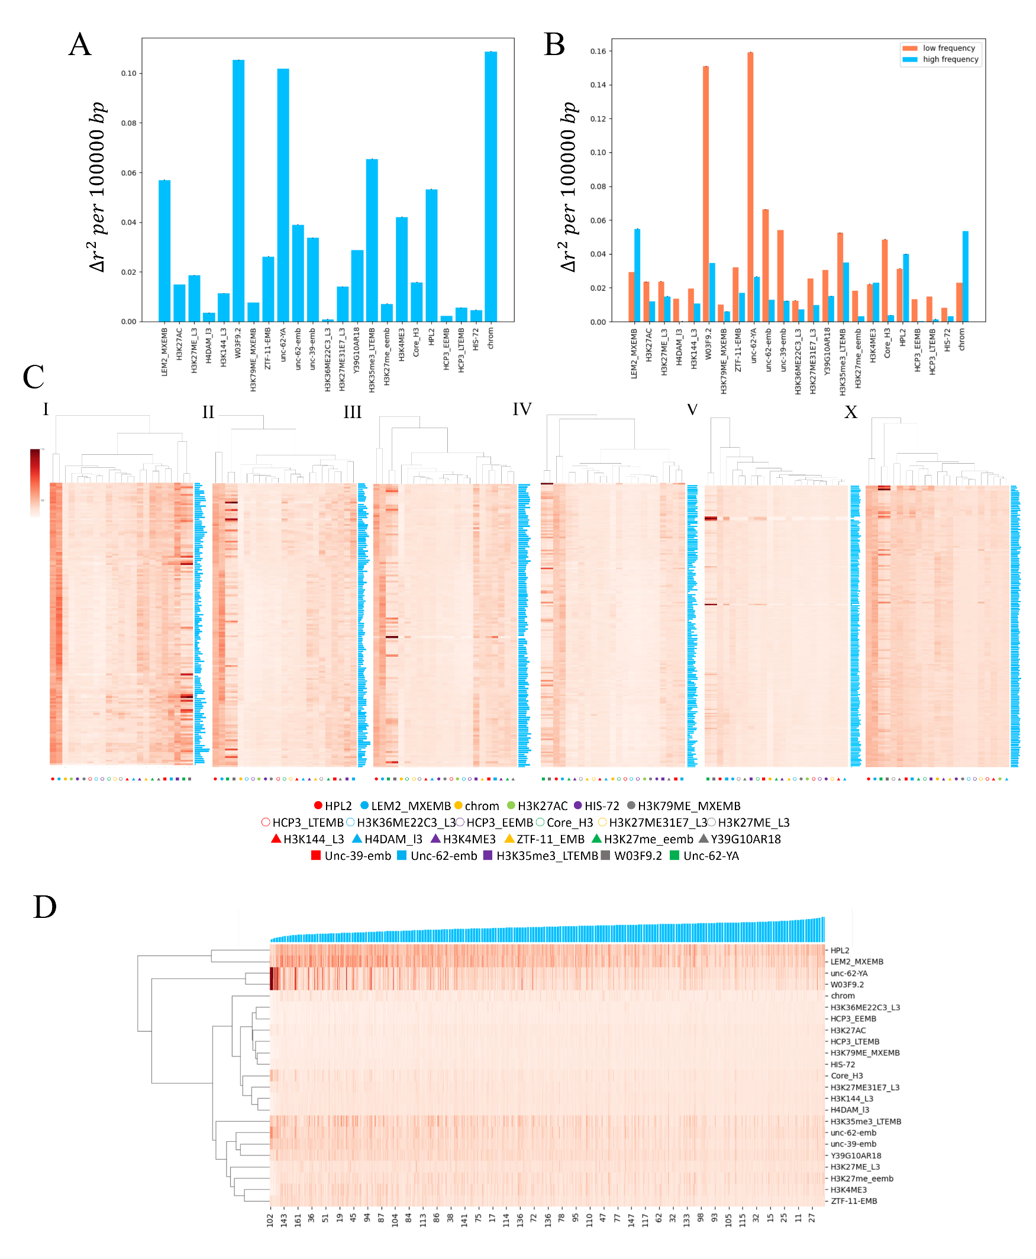

**Figure 6. Feature importance of model II.**

A) The permutation importance of each feature B) The permutation importance of each feature in the high mutation frequency region and low mutation frequency region. C) The permutation importance along each chromosome, mutation frequency was shown as a bar chart in the right side of the heatmap. D) The permutation importance of each feature sorted by the mutation frequency shown as a bar chart above.

|  |  |  |  |
| --- | --- | --- | --- |
| Feature name | Information | Resource |  |
| Chrom | Which chromosome the base belongs to | Reference genome WS235 |  |
| Code | $P_{0}$ or ‘pentabase bias’ | Calculated with the MMP dataset |  |
| HPL2 | ChIP-chip of L3 worm targeting heterochromatin protein HPL2 | [**GSE40947**](https://www.ncbi.nlm.nih.gov/geo/query/acc.cgi?acc=GSE40947) |  |
| LEM2_MXEMB | ChIP-chip of mixed-stage embryo targeting nuclear envelope protein LEM2 | [**GSM562786**](https://www.ncbi.nlm.nih.gov/geo/query/acc.cgi?acc=GSM562786) |  |
| unc-62-YA | ChIP-seq of day4 young adult worm targeting transcription factor unc-62 | [**GSM942047**](https://www.ncbi.nlm.nih.gov/geo/query/acc.cgi?acc=GSM942047) |  |
| W03F9.2 | ChIP-seq of day4 young adult worm targeting transcription factor W03F9.2 | [**GSM729307**](https://www.ncbi.nlm.nih.gov/geo/query/acc.cgi?acc=GSM729307) |  |
| H3K36ME22C3_L3 | ChIP-chip of early embryo targeting K36-trimethylated histone H3 | [**GSE22719**](https://www.ncbi.nlm.nih.gov/geo/query/acc.cgi?acc=GSE22719) |  |
| HCP3_EEMB | ChIP-chip of early embryo targeting holocentric chromosome binding protein HCP3 | [**GSM1255286**](https://www.ncbi.nlm.nih.gov/geo/query/acc.cgi?acc=GSM1255286) |  |
| H3K27Ac | ChIP-chip of early embryo targeting K27-acetylated histone H3 | [**GSM562779**](https://www.ncbi.nlm.nih.gov/geo/query/acc.cgi?acc=GSM562779) |  |
| HCP3_LTEMB | ChIP-chip of late embryo targeting holocentric chromosome binding protein HCP3 | [**GSM1255289**](https://www.ncbi.nlm.nih.gov/geo/query/acc.cgi?acc=GSM1255289) |  |
| H3K79ME_MXEMB | ChIP-chip of mixed-stage embryo K79-trimethylated histone H3 | [**GSM562779**](https://www.ncbi.nlm.nih.gov/geo/query/acc.cgi?acc=GSM562779) |  |
| HIS-72 | DNA tilling array of mixed-stage embryo; strain: JJ2061 | [www.modencode.org](http://www.modencode.org) 5326 |  |
| Core_H3 | ChIP-chip of L3 worm targeting histone H3 | [**GSM1005484**](https://www.ncbi.nlm.nih.gov/geo/query/acc.cgi?acc=GSM1005484) |  |
| H3K27ME31E7_L3 | ChIP-chip of L3 worm targeting K27-trimethylated histone H3 | [**GSM562735**](https://www.ncbi.nlm.nih.gov/geo/query/acc.cgi?acc=GSM562735) |  |
| H3144_L3 | ChIP-chip of L3 worm targeting histone H3 | [**GSM562745**](https://www.ncbi.nlm.nih.gov/geo/query/acc.cgi?acc=GSM562745) |  |
| H4DAM_L3 | ChIP-chip of L3 worm targeting histone H4 | [**GSM624427**](https://www.ncbi.nlm.nih.gov/geo/query/acc.cgi?acc=GSM624427) |  |
| H3K36me3_LTEMB | ChIP-chip of late embryo targeting K36-trimethylated histone H3 | [**GSM811293**](https://www.ncbi.nlm.nih.gov/geo/query/acc.cgi?acc=GSM811293) |  |
| unc-62-emb | ChIP-seq of mixed-stage embryo targeting transcription factor unc-62 | [**GSE48731**](https://www.ncbi.nlm.nih.gov/geo/query/acc.cgi?acc=GSE48731) |  |
| unc-39-emb | ChIP-seq of mixed-stage embryo targeting transcription factor unc-39 | [**GSE46775**](https://www.ncbi.nlm.nih.gov/geo/query/acc.cgi?acc=GSE46775) |  |
| Y39G10AR18 | ChIP-chip of mixed-stage embryo targeting transcription factor Y39G10AR18 | [**GSM811254**](https://www.ncbi.nlm.nih.gov/geo/query/acc.cgi?acc=GSM811254) |  |
| H3K27ME_L3 | ChIP-chip of L3 worm targeting K27-trimethylated histone H3 | [**GSM562735**](https://www.ncbi.nlm.nih.gov/geo/query/acc.cgi?acc=GSM562735) |  |
| H3K27me_eemb | ChIP-chip of early embryo targeting K27-trimethylated histone H3 | [**GSM811255**](https://www.ncbi.nlm.nih.gov/geo/query/acc.cgi?acc=GSM811255) |  |
| H3K4ME3 | ChIP-chip of L2 worm targeting K4-trimethylated histone H3 | [**GSM811289**](https://www.ncbi.nlm.nih.gov/geo/query/acc.cgi?acc=GSM811289) |  |
| ZTF-11-EMB | ChIP-seq of mixed-stage embryo targeting zinc finger putative transcription factor ztf-11 | [**GSE48746**](https://www.ncbi.nlm.nih.gov/geo/query/acc.cgi?acc=GSE48746) |  |

**Table.1 Feature information**

**Discussion**

In this article, I proposed a novel approach to find valuable mutations in genetic screening using EMS as the mutagen, by making a mutation probability map that predict mutation frequency of each genomic position of *C. elegans* genome. I utilized machine learning to correlate the frequency of EMS-induced mutations found in the WGS results of more than 700 mutants (MMP) to the results of genome-wide DNA-binding protein analyses such as histone modification and DNA-binding proteins, and the bias of flanking sequences next to the mutated site, which was revealed by analyses of MMP (model I). It was successfully applied to novel genetic screenings and effectively predicted candidate genes that have been subsequently confirmed through rescue experiments. Thus, EMS probability map is a simple and effective approach for finding responsible mutations in *C. elegans* that does not require genetic mapping steps. Regarding the resolution, this map provides the mutation probability of every base pair, which enables us to predict how likely the base is mutated by EMS in a WGS dataset. Also, it is qualified to deal with the forward screening data and small size data with a lower mutation anticipation of each gene.

Model II was trained to analyze the data of DNA-binding protein analyses and mutation frequencies separately from the flanking-sequences-based probability (pentabase bias, $P_{0}$). The performance of model II in predicting the high-frequency regions was not as good as model I. It seems that in model II, $P=αf\left(x'\right)*P_{0}$, cannot reflect the relationship and interaction between Pentabase bias and DNA-binding protein features. There might be some unknown interaction between Pentabase bias and DNA-binding protein features in high-frequency regions, making the high-frequency regions cannot be correctly predicted by $x'$ without the flanking sequence information. In the feature importance evaluation, unlike the cases in low-frequency regions, high-frequency regions were not strongly represented by any features. It is ambiguous to tell the exact function of the DNA-binding protein used as features of each base. On those silent regions, the most likely situation is that there is a strong DNA-protein binding protein signal or exact the opposite situation (Fig.3). The previous one can be understood as that the special region on genome is wrapped up with DNA-binding proteins, which made it hard to interact with outside substances. The second situation might be that the special region of genome has a super-coiled 3D structure, which made anything hard to be involved. However, according to the study, there are many DNA-binding proteins which made minor but important adjustment to the mutation probability of the base pairs with average mutation probability. (Fig.5 D) To study the interaction between $P_{0}$ and $f\left(x'\right)$, a new model should be built to investigate this kind of interaction.

There might be features vital for the prediction of the high-frequency regions among those unselected features. Some DNA-binding proteins interact with particular sequence motifs (Barrows & Van Dyke, 2023), and transcription factors often bind to specific sequences (Lambert et al., 2018), competing or interacting with nucleosomes. This might be part of the interactions between the flanking sequences and $f\left(x'\right)$ in model II, which can be compensated by introducing more features into this model. In another word, the EMS mutation frequency as well as DNA-binding protein features, which could be discovered in further study, might have interaction with the local DNA sequence to some extent.

In the commonly used procedure of EMS mutagenesis in *C. elegans*, synchronized L4 worms are mutagenized (Kutscher & Shaham, 2014). DNA-binding protein features used in the current study were collected from different developmental stages from early embryo to 4-day young adult, therefore some of these would not represent the state of germ cells (which expand in late larval stages). However, by using these DNA-binding protein data the model successfully predicted mutation probability in a good resolution and accuracy, suggesting a possibility that the chromosome status in germ cells might be estimated based on the non-germ-cell data. Also, unc-62-YA showed a better importance value during the permutation importance evaluation than other unc-62 datasets, suggesting that young adult might be the stage with DNA-binding protein distribution close to the germ cells.

**Reference**

Altmann, A., Toloşi, L., Sander, O., & Lengauer, T. (2010). Permutation importance: a corrected feature importance measure. *Bioinformatics, 26*(10), 1340-1347. doi:10.1093/bioinformatics/btq134

Arnold, A. R., & Barton, J. K. (2013). DNA protection by the bacterial ferritin Dps via DNA charge transport. *J Am Chem Soc, 135*(42), 15726-15729. doi:10.1021/ja408760w

Barrows, J. K., & Van Dyke, M. W. (2023). Using Restriction Endonuclease, Protection, Selection, and Amplification to Identify Preferred DNA-Binding Sequences of Microbial Transcription Factors. *Microbiol Spectr*, e0439722. doi:10.1128/spectrum.04397-22

Bowater, R. P., Bohálová, N., & Brázda, V. (2022). Interaction of Proteins with Inverted Repeats and Cruciform Structures in Nucleic Acids. *Int J Mol Sci, 23*(11). doi:10.3390/ijms23116171

Breiman, L. (2001). Random Forests. *Machine Learning, 45*, 5-32. doi:10.1023/A:1018054314350

Brenner, S. (1974). The genetics of Caenorhabditis elegans. *Genetics, 77*(1), 71-94. doi:10.1093/genetics/77.1.71

Cheesman, H. K., Feinbaum, R. L., Thekkiniath, J., Dowen, R. H., Conery, A. L., & Pukkila-Worley, R. (2016). Aberrant Activation of p38 MAP Kinase-Dependent Innate Immune Responses Is Toxic to Caenorhabditis elegans. *G3 (Bethesda), 6*(3), 541-549. doi:10.1534/g3.115.025650

Cho, J. Y., Choi, T. W., Kim, S. H., Ahnn, J., & Lee, S. K. (2021). Morphological Characterization of small, dumpy, and long Phenotypes in Caenorhabditis elegans. *Mol Cells, 44*(3), 160-167. doi:10.14348/molcells.2021.2236

Doitsidou, M., Jarriault, S., & Poole, R. J. (2016). Next-Generation Sequencing-Based Approaches for Mutation Mapping and Identification in Caenorhabditis elegans. *Genetics, 204*(2), 451-474. doi:10.1534/genetics.115.186197

Doitsidou, M., Poole, R. J., Sarin, S., Bigelow, H., & Hobert, O. (2010). C. elegans mutant identification with a one-step whole-genome-sequencing and SNP mapping strategy. *PLoS One, 5*(11), e15435. doi:10.1371/journal.pone.0015435

Drake, J. W., & Baltz, R. H. (1976). The biochemistry of mutagenesis. *Annu Rev Biochem, 45*, 11-37. doi:10.1146/annurev.bi.45.070176.000303

Flibotte, S., Edgley, M. L., Chaudhry, I., Taylor, J., Neil, S. E., Rogula, A., . . . Moerman, D. G. (2010). Whole-genome profiling of mutagenesis in Caenorhabditis elegans. *Genetics, 185*(2), 431-441. doi:10.1534/genetics.110.116616

Hillier, L. W., Marth, G. T., Quinlan, A. R., Dooling, D., Fewell, G., Barnett, D., . . . Mardis, E. R. (2008). Whole-genome sequencing and variant discovery in C. elegans. *Nat Methods, 5*(2), 183-188. doi:10.1038/nmeth.1179

Ike, Y., Tomioka, M., & Iino, Y. (2022). Involvement of HECT-type E3 ubiquitin ligase genes in salt chemotaxis learning in Caenorhabditis elegans. *Genetics, 220*(4). doi:10.1093/genetics/iyac025

An integrated encyclopedia of DNA elements in the human genome. (2012). *Nature, 489*(7414), 57-74. doi:10.1038/nature11247

Joseph, B. B., Blouin, N. A., & Fay, D. S. (2018). Use of a Sibling Subtraction Method for Identifying Causal Mutations in Caenorhabditis elegans by Whole-Genome Sequencing. *G3 (Bethesda), 8*(2), 669-678. doi:10.1534/g3.117.300135

Kutscher, L. M., & Shaham, S. (2014). Forward and reverse mutagenesis in C. elegans. *WormBook*, 1-26. doi:10.1895/wormbook.1.167.1

Lambert, S. A., Jolma, A., Campitelli, L. F., Das, P. K., Yin, Y., Albu, M., . . . Weirauch, M. T. (2018). The Human Transcription Factors. *Cell, 175*(2), 598-599. doi:10.1016/j.cell.2018.09.045

Minevich, G., Park, D. S., Blankenberg, D., Poole, R. J., & Hobert, O. (2012). CloudMap: a cloud-based pipeline for analysis of mutant genome sequences. *Genetics, 192*(4), 1249-1269. doi:10.1534/genetics.112.144204

Mohammad, A., & Jha, S. (2022). Epimutations and Their Effect on Chromatin Organization: Exciting Avenues for Cancer Treatment. *Cancers (Basel), 15*(1). doi:10.3390/cancers15010215

Muers, M. (2011). Functional genomics: the modENCODE guide to the genome. *Nat Rev Genet, 12*(2), 80. doi:10.1038/nrg2942

Sarin, S., Bertrand, V., Bigelow, H., Boyanov, A., Doitsidou, M., Poole, R. J., . . . Hobert, O. (2010). Analysis of multiple ethyl methanesulfonate-mutagenized Caenorhabditis elegans strains by whole-genome sequencing. *Genetics, 185*(2), 417-430. doi:10.1534/genetics.110.116319

Sarin, S., Prabhu, S., O'Meara, M. M., Pe'er, I., & Hobert, O. (2008). Caenorhabditis elegans mutant allele identification by whole-genome sequencing. *Nat Methods, 5*(10), 865-867. doi:10.1038/nmeth.1249

Sonnichsen, B., Koski, L. B., Walsh, A., Marschall, P., Neumann, B., Brehm, M., . . . Echeverri, C. J. (2005). Full-genome RNAi profiling of early embryogenesis in Caenorhabditis elegans. *Nature, 434*(7032), 462-469. doi:10.1038/nature03353

Vergara, I. A., Tarailo-Graovac, M., Frech, C., Wang, J., Qin, Z., Zhang, T., . . . Chen, N. (2014). Genome-wide variations in a natural isolate of the nematode Caenorhabditis elegans. *BMC Genomics, 15*, 255. doi:10.1186/1471-2164-15-255

Wicks, S. R., Yeh, R. T., Gish, W. R., Waterston, R. H., & Plasterk, R. H. (2001). Rapid gene mapping in Caenorhabditis elegans using a high density polymorphism map. *Nat Genet, 28*(2), 160-164. doi:10.1038/88878

Zhu, Q., Fu, Y., Li, L., Liu, C. H., & Zhang, L. (2021). The functions and regulation of Otubains in protein homeostasis and diseases. *Ageing Res Rev, 67*, 101303. doi:10.1016/j.arr.2021.101303